PROGRAM FOLDER
PROGRAM ID: TSLTradeFinance
Version 0.0.7

TATA STEEL

Table of Contents

Contents
1. Change History 2
2. Customer Requirement 2
3. Technology Used 3
4. Interface with other systems, modules or programs 3
5. Product Requirements 3
6. Architecture 3
7. Process Flow 6
8. Number of users who will use the program 6
9. Security privileges of the program 6

Program Specification
Program ID : TradeFinancePain001Microservice
Program Description : This program generate Pain001 messages and process Pain002 messages. This program runs on background.

1. Change History
Version | CMR No | Date | Author | Description
V0.0.7 |  | 02.06.2022 | Jamil | 1. pian001-generator going live  2. swift-notfication going live  3. pain002-receiver going live
v0.0.8 |  | 15.06.2022 | Jamil | 1. Email notification added if pain001 generation failed.  2. Delay of at least 3 sec is added between approval of a transaction and pain001 msg generation.  3. If updating of the status of the txn is failure, temporary files will be deleted.

2. Customer Requirement
It is a part of TSLTradeFinance project which deals with generating and processing Pain001 and Pain002 messages. The generated Pain001 messages are sent to the bank through SWIFT and process Pain002 messages issued by the bank received through swift.

3. Technology Used
GoLang, fabric-go-sdk

4. Interface with other systems, modules or programs
TradeFinanceRESTServer

5. Product Requirements
It is service that controls the execution of 3 micro-services. Please refer to the below table
Sl No | Microservice Name | Description
1 | pain001-generator | This service generates set of Pain001 for LC Issuance.
2 | swift-notification | This service reads the NetAck and DeliverNotif files and update the status of the transaction
3 | pain002-receiver | This service process the Pain002 messages from SWIFT and process it. When all the parts of Pain002 (if any attachment) message are received, the status of the corresponding message is updated.

6. Architecture

6.1 Architecture of Pain001 Microservice

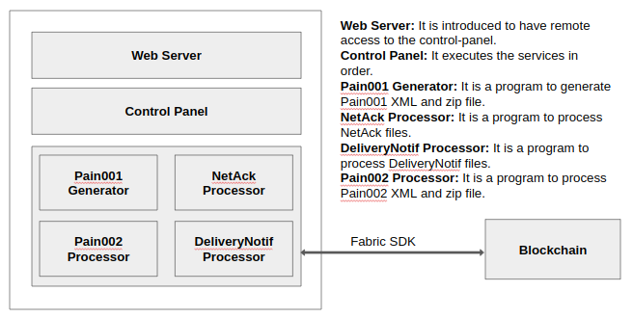

7. Process Flow
7.1 Process Flow for swift-notificaiton
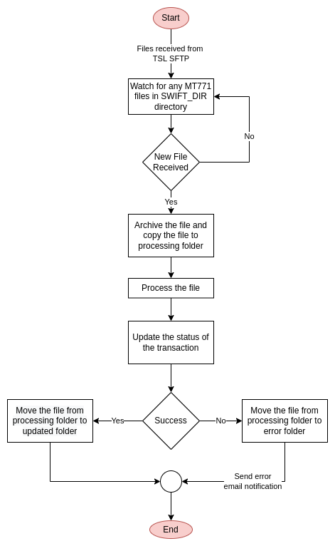

7.2 Process Flow for pain001-generator service

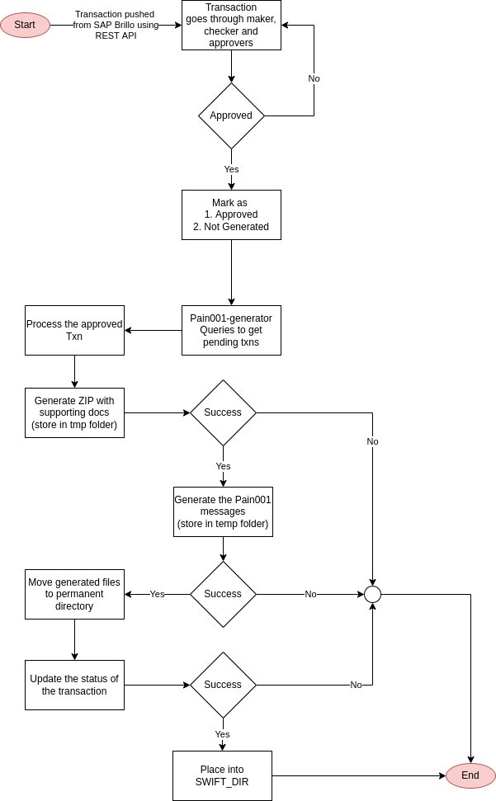

7.3 Process Flow for pain002-receiver service

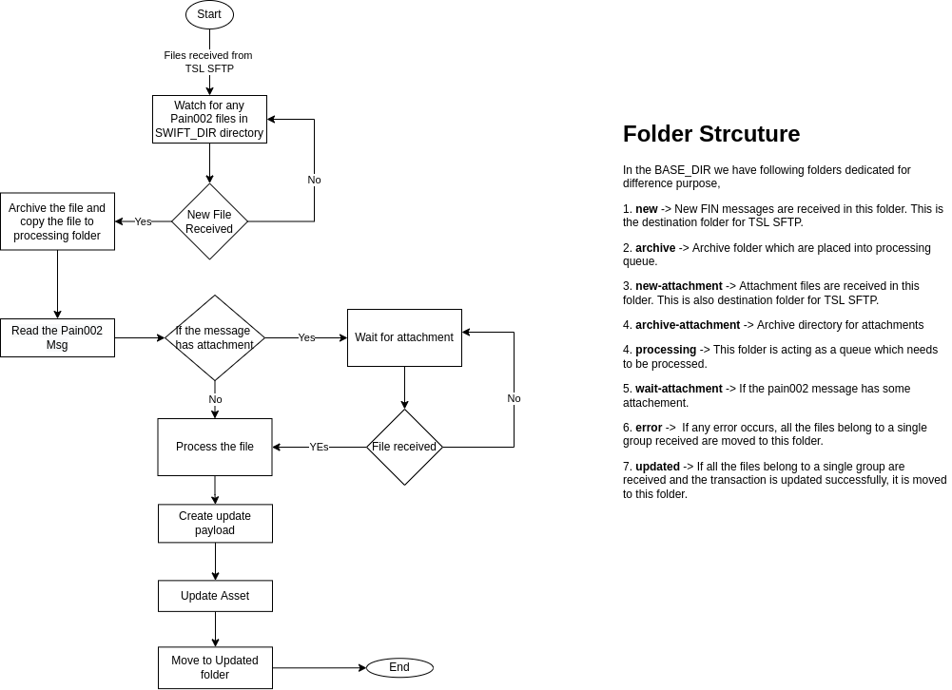

8. Number of users who will use the program
This program runs on background and part of the application. No direct interaction is available.

9. Security privileges of the program
This program is not exposed to external world. It only communicates with hyperledger network which is TLS protected

